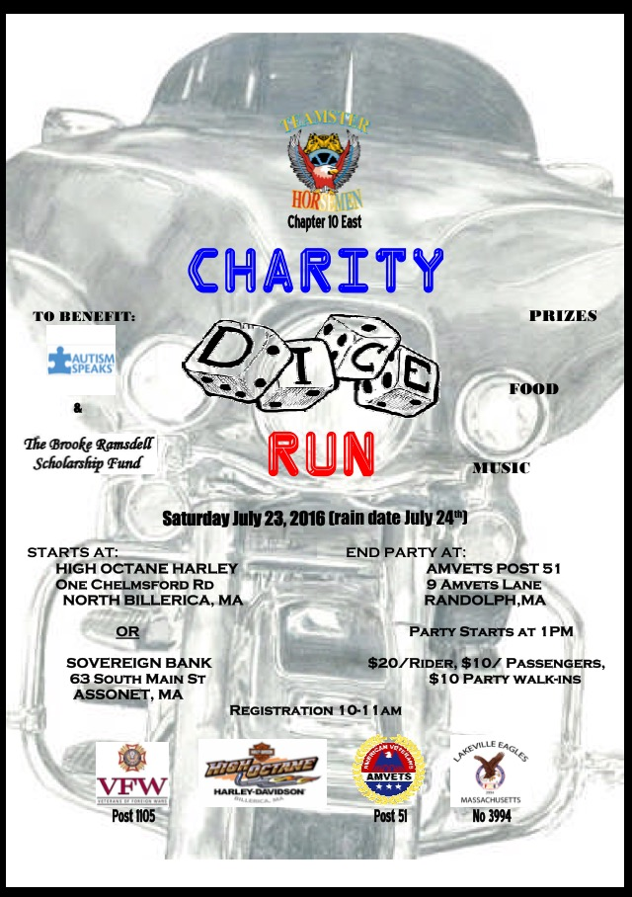

**Sunday July 23, 2017 RAIN OR SHINE**

**REGISTRATION 10AM – 11AM**