THMA10E GEORGE HEATH SUPERHERO SCHOLARSHIP MEMORIAL RUN

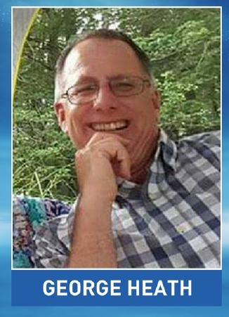

SUNDAY JUNE 10TH 2018 RAIN OR SHINE
REGISTRATION 10AM @ NB VOC TECH HIGH SCHOOL 1121 ASHLEY BLVD NEW BEDFORD
KSU@11:30 SHARP
ENDING @ PORTUGUESE- AMERICAN CIVIC CLUB 175 SCHOOL ST TAUNTON
ALL WELCOME
NO MOTORCYCLE NECESSARY TO ENJOY FESTIVITIES FROM NOON – 4PM JUST WALK IN!!
POLICE ESCORTED RIDE FOOD RAFFLES 50/50
MUSIC BY LED ZEPPELIN COVER BAND: HEARTBREAKER
RIDERS $20 – PASSENGERS $10 – WALK IN’S $10

