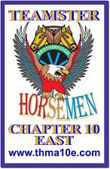
George Heath Superhero Scholarship memorial run
January 01, 2018

Dear Friend,
Teamster Horsemen Motorcycle Association Chapter 10 East is hosting “The George Heath Superhero Scholarship fund” memorial motorcycle run on June 10th. It is beginning at the Greater New Bedford Regional Vocational Technical High School 1121 Ashley Boulevard New Bedford and ending at the Pines Lafayette on Bay Street Taunton.
All proceeds shall be donated to Greater New Bedford Voc-Tech Education Foundation into the George Heath Superhero Scholarship fund designed for any student who has gone above and beyond their self, looking out for someone else as George did by selflessly sacrificing his life to save another. All donations are Tax deductible under Tax ID# 47-1823527
Our event is public and all are welcome to attend. Please consider making a contribution to our event. Some friends chose to donate in the form of an item that we may raffle to earn more monetary funds for this worthwhile cause. Any help will be greatly appreciated. We thank you for consideration and hope to see you at our event.

Sincerely,
Teamster Horsemen chapter 10E

PO Box 132, Assonet MA, 02720
www.thma10e.com

